Jaskarn Jagpal

04/25/2016

Csc 135 T, TH 130-245

Assignment 3: Logic Programming

1. Complete the following sentences:
   1. Logic programming systems are also called deductive databases.
   2. The process of pattern matching to make statements identical is called unification.
2. Give a concise answer to each question below:
   1. What are the differences between procedural programming and logic programming?
      1. Procedural and logic programming differ in architecture, syntax, computation and control.
      2. Procuedural
         1. Von Neumann machine architecture (sequential steps).
         2. Syntax is a sequence of statements.
         3. Performs sequential statements execution.
         4. Logic and control are mixed together.
      3. Logic Programming
         1. Abstract model, dealing with objects and their relationships.
         2. Logic formulas (Horn clauses)
         3. Computation is a deduction of clauses.
         4. Logic and control can be separated
   2. What are the deficiencies of Prolog?
      1. Resolution order control
         1. Ordering of pattern matching during resolution.
         2. Cut operator
      2. Closed world assumption
         1. It has only the knowledge of its database
         2. A true/fail system rather than a true/false
      3. The negation problem
         1. Prolog not operator is not equivalent to logical NOT operator.
   3. What are the motivations for Logic programming?
      1. Logic is used to represent the program
      2. Deduction are used as computation.
      3. A higher level language does more automatically
         1. We can concentrate more on what is to be done and less on how to do it.
      4. Ideal because the algorithm is the logic (the what) and the Control (the how)
         1. Only specific logic and let the system take care of control.
3. Use set notation to describe the resolution as a refutation system.
   1. Given a set of clauses S & and goal G,
      1. Negate the goal G
      2. {S} U {¬G}
      3. existence of contradiction => derivation of empty clause
      4. Based on {S} U {¬G} is inconsistent if {S} U {G} is consistent.
4. Give deduction trees of resolution (a) using 1 and 5; (b) using 2 and 5.

(1) anc (X, Y) V ~par ( X, Y)

(2) anc (X, Y) V ~par(X, Z) V ~ac(Z, Y)

(3) par (d, b)

(4) par (b, m)

(5) ~anc (X, m)

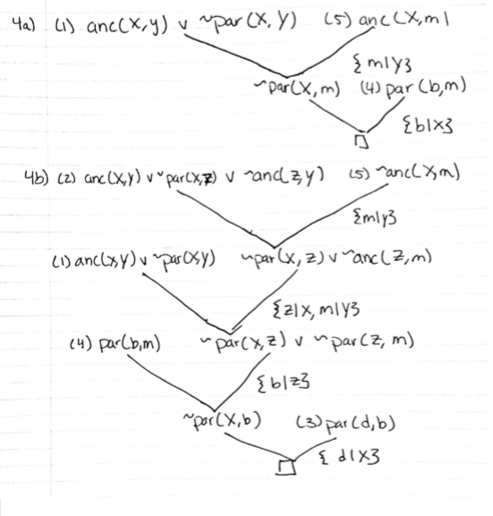

1. Conjunctions and Backtracking. Using the example of “Who teaches what”
   1. Try to trace through the search process for Q2.:

**Call: (8) teaches(G3373, os, _G3375) ? creep**

**Exit: (8) teaches(mary, os, s1) ? creep**

**Call: (8) teaches(mary, compiler, _G3379) ? creep**

**Fail: (8) teaches(mary, compiler, _G3379) ? creep**

**False.**

* 1. Try to trace through Q1, but with sub-goals reversed.

**Call: (8) teaches(mary, _G832, _G833) ? creep**

**Exit: (8) teaches(mary, os, s1) ? creep**

**Call: (8) teaches(john, os, _G837) ? creep**

**Fail: (8) teaches(john, os, _G837) ? creep**

**Redo: (8) teaches(mary, _G832, _G833) ? creep**

**Exit: (8) teaches(mary, ai, s2) ? creep**

**Call: (8) teaches(john, ai, _G837) ? creep**

**Exit: (8) teaches(john, ai, s1) ? creep**

**X = ai .**

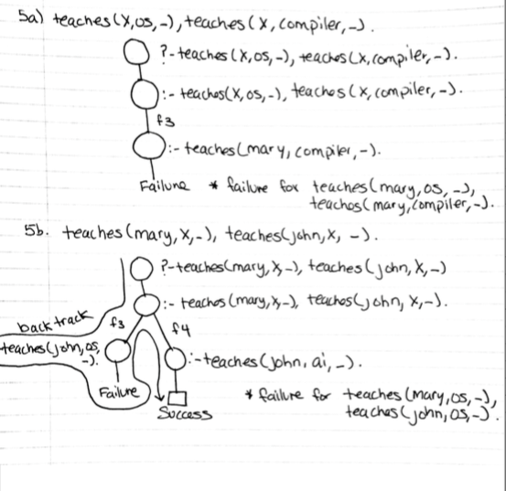

1. Exam problem contribution
   1. Write a PROLOG representation of the following facts: (your at least 5 facts in English);
      1. **nbaplayer(kobe).**
      2. **nbaplayer(curry).**
      3. **nbaplayer(Jordan).**
      4. **nbaplayer(westbrook).**
      5. **greatestLakerPlayer(kobe).**
      6. **greatestBullsPlayer(Jordan).**
      7. **greatestwarriorsplayer(curry).**
      8. **greatestokcplayer(westbrook).**
   2. Write a PROLOG representation of the following rule: (your at least 3 rules in English);
      1. **bestplayerfromwest(X,Y):-greatestLakerPlayer(X), greatestwarriorsplayer(Y).**
      2. **bestplayerfromeast(X,Y):-greatestBullsPlayer(X), greatestokcplayer(Y).**
      3. **bestofboth(X, Y):-bestplayerfromwest(X, Y).**
      4. **bestofboth(X, Y):- bestplayerfromeast(X,Y).**
   3. Write two PROLOG goal statements to search for answers: (also give 2 W questions in English), and at least one of your goal statements should be a conjunction of two sub goals;
      1. Who is the basketball player from the west and on the Lakers team?
         1. **?- bestplayerfromthewestX), greatestLakerPlayer(X).**
      2. Who are the best basketball players from the west?
         1. **?-bestplayersfromwest(X, Y).**
   4. Run each given query.

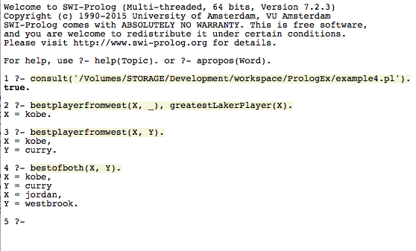

* 1. Show deduction tree that deduced the answer for one of the W questions above according to Prolog search strategy.

